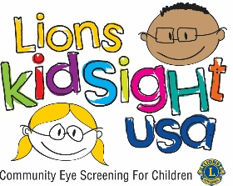
WISCONSIN LIONS FOUNDATION
(YOUR COUNTY HERE) COUNTY LIONS

VISION SCREENING PERMISSION FORM
Dear Parents,
A free vision screening will be offered for your child(ren) on:
________________________________.
Personnel trained by KidSight USA will administer the screening.
Since one out of every twenty preschoolers and one out of every four school age children has a vision problem that needs the attention of an eye care professional, it is important for your child’s vision to be checked.

This vision screening does not replace a professional eye examination. Screening is designed to detect those children who may have a vision problem.

If there is any concern about your child’s results after screening, a referral form will be sent home. A referral does not mean your child needs glasses or treatment. It means your child’s vision needs to be examined by an eye care professional. If your child wears glasses, please make sure they wear them on the day of testing.

We ask that you please sign this Permission Form below and return it to the school by

___________________________________________________.

Thank you for your cooperation.

Lions (NAME HERE) & (NAME HERE)
Vision Screening Coordinators
(YOUR COUNTY HERE) County Lions
- - - - - - - - - - - - - - - - - - - - - - - - - - - - - - - - - - - - - - - - - - - - - - - - - - - - - - - - - - - - - - - - - - - - - - - - - - -
Return this portion to your school

I hereby give permission for my child __________________________________________________

to participate in the vision screening conducted by the Wisconsin Area Lions Clubs

Parent signature: ___________________________________________________ Date: _____________

